* Create a instance and install Terraform in that instance

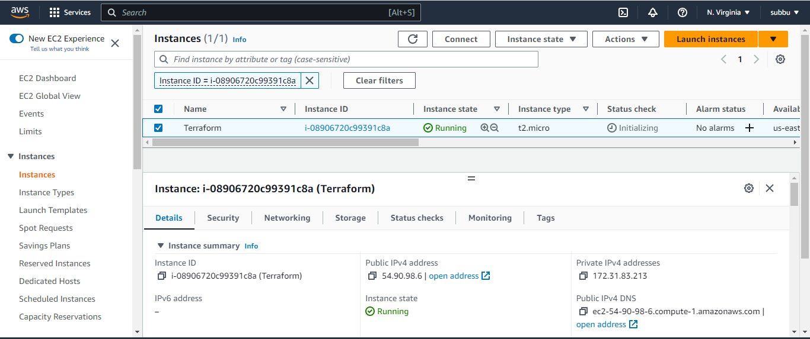

* Download Terraform and install in linux

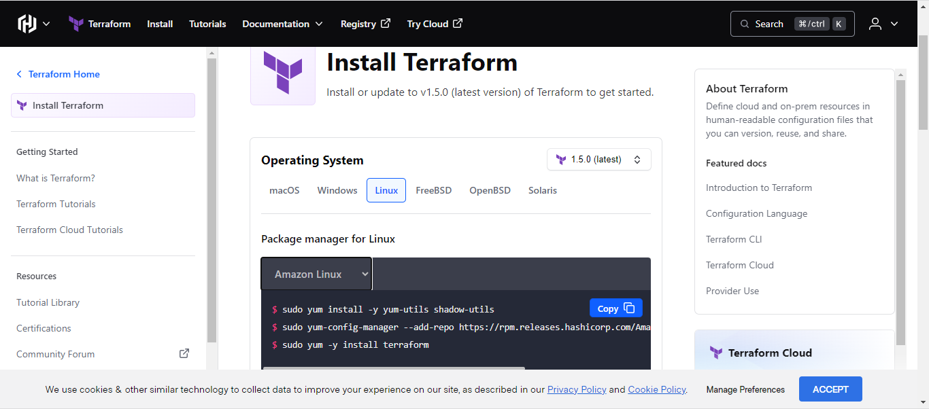

* Creating provider.tf and use terraform init (it will create terraform directory )

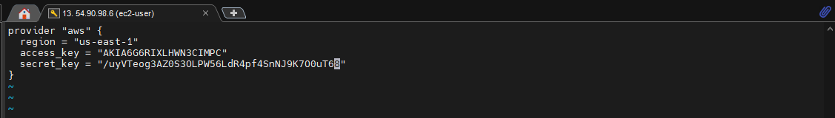

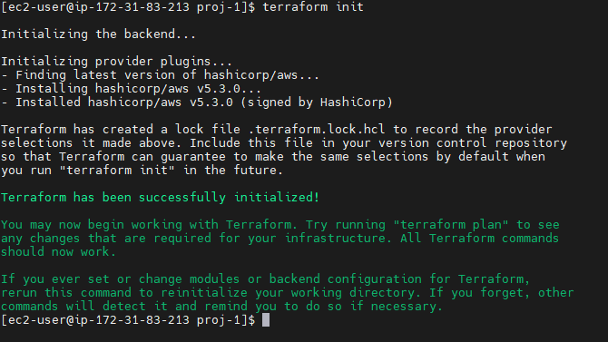

Task – 2:

* Create a vpc.tf and write script for vpc creation

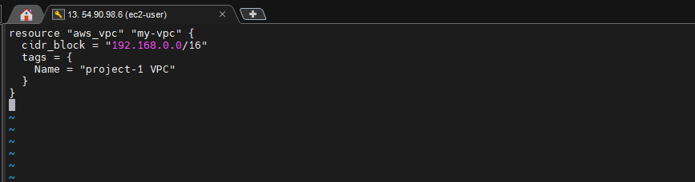

* After creating the vpc file go for terraform validate and terraform plan to check whether the resource is building or not.

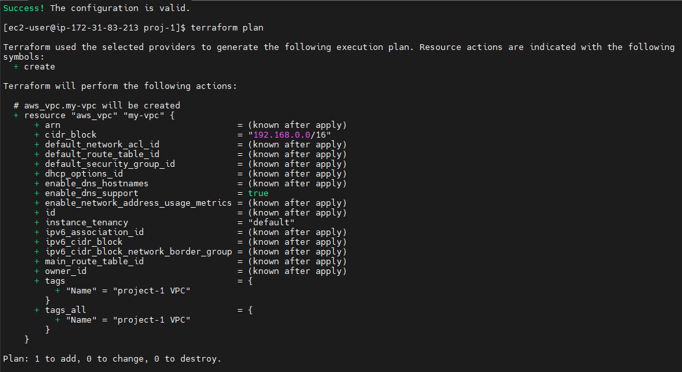

* Create subnet.tf and write public and private subnets

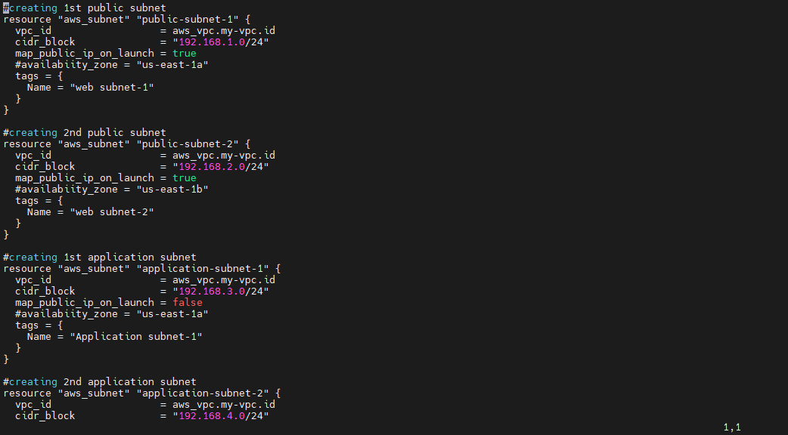

* Use terraform validate , terraform plan and terraform apply. So that it will create the resources like vpc and subnets

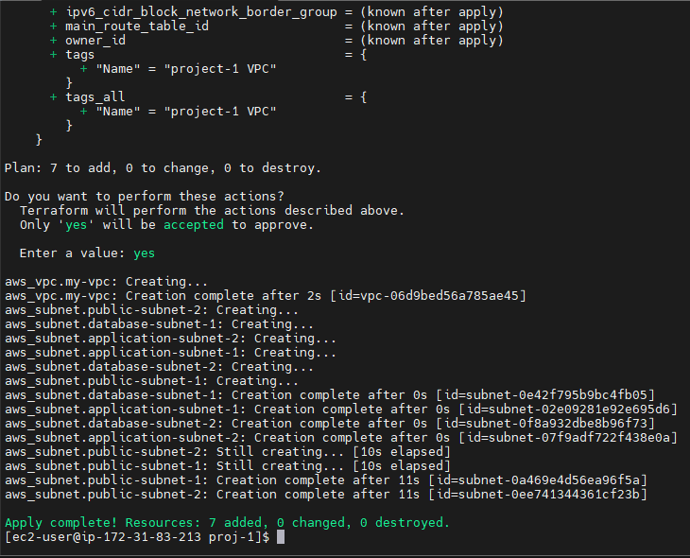

* Now check AWS console

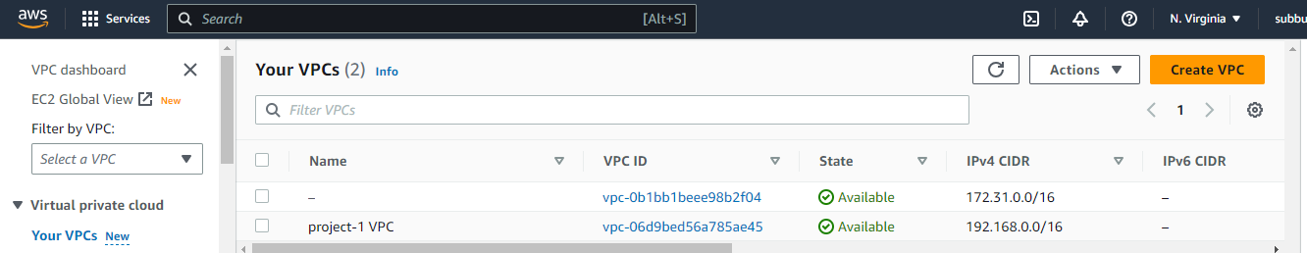

VPC created

* Subnets created

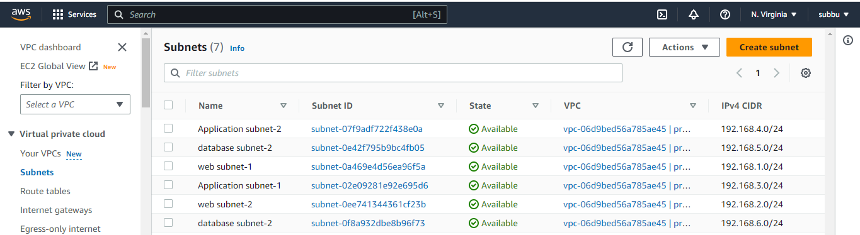

* Create Internet Gateway

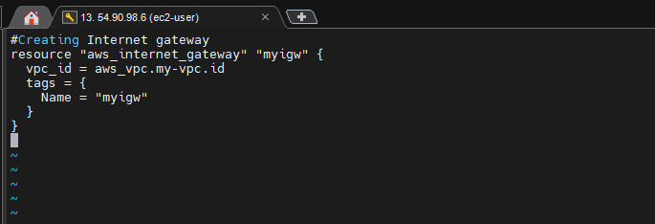

* Create Route table

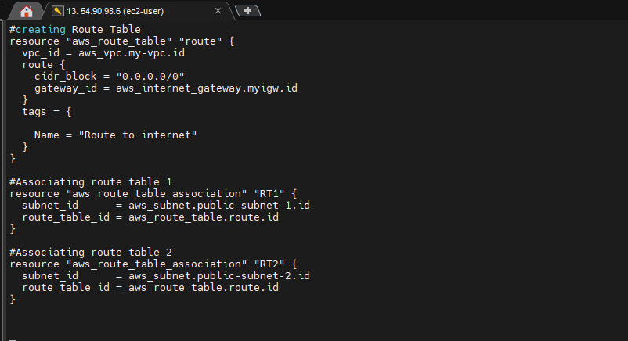

* Now validate and plan for igw.tf and route_table.tf

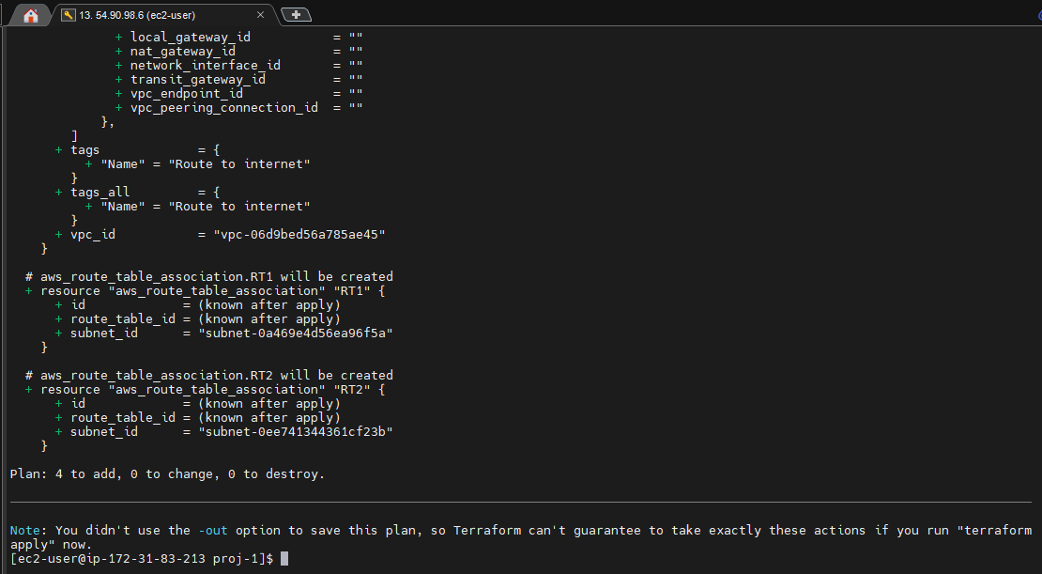

* Create security-group file for frontend

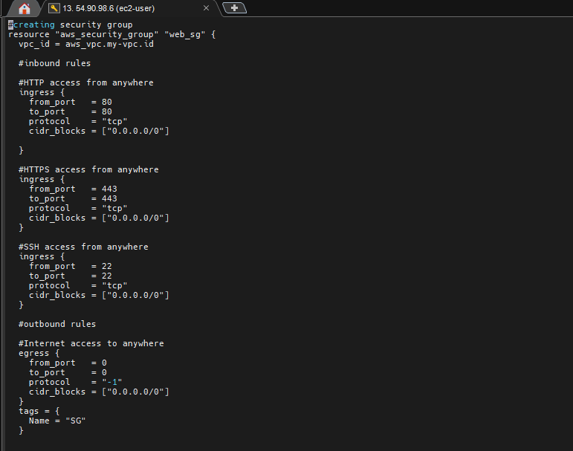

* Create security-group file for database

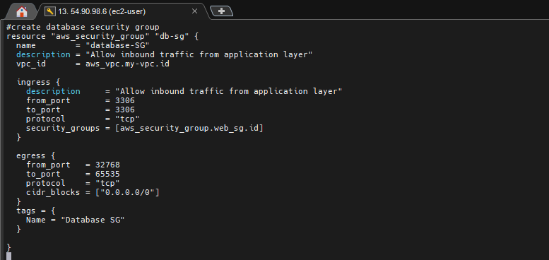

* Now validate and plan web_sg.tf and db_sg.tf

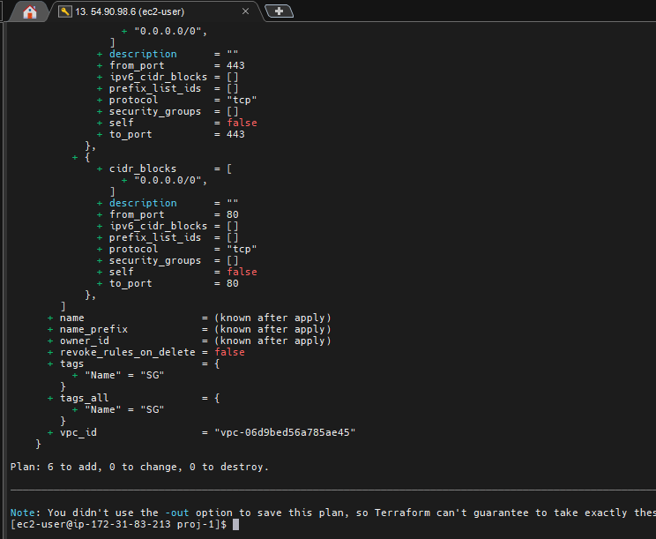

* Create a file to create EC2 instance

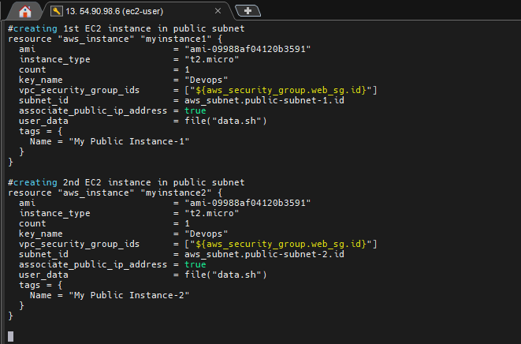

* Create data.sh file

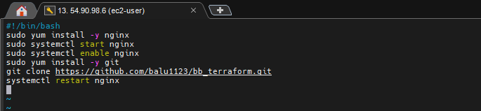

* Test the resources by using terraform Validate and plan

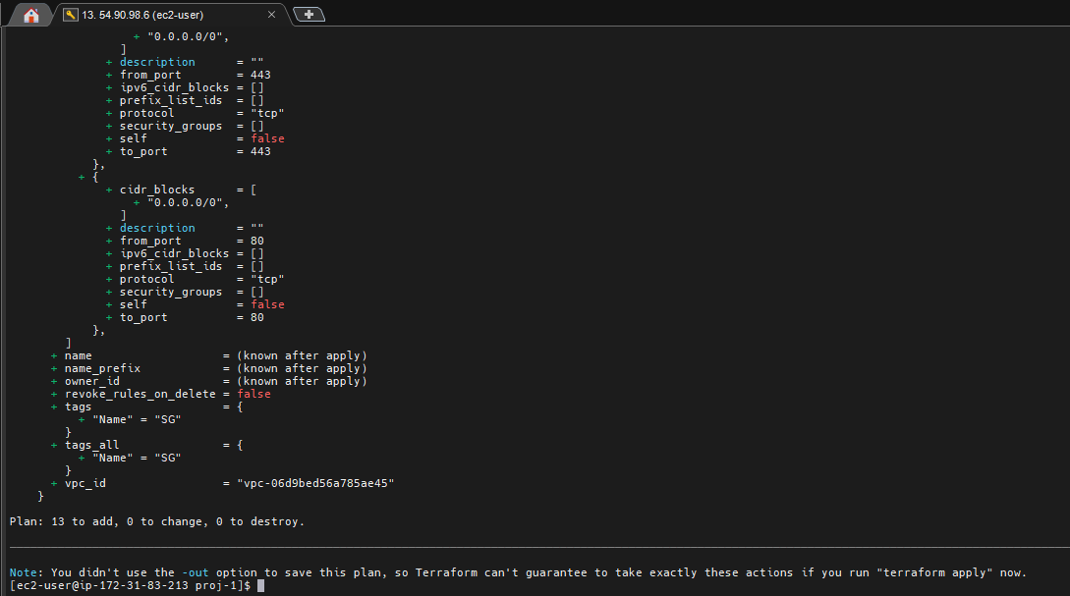

* Create a file for application load balancer

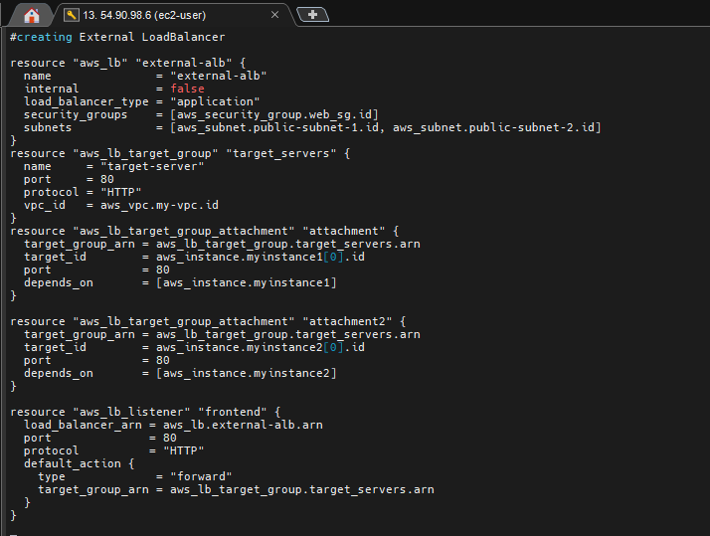

* Create a file for RDS instance

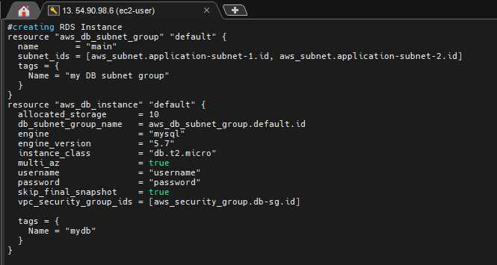

* Test the resources by using terraform Validate and plan

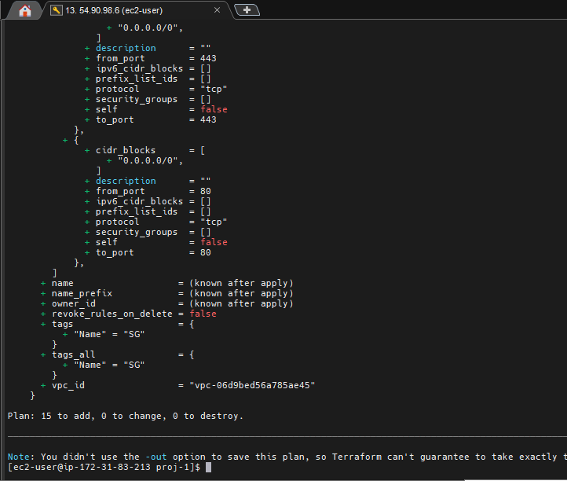

* Now apply the terraform apply command

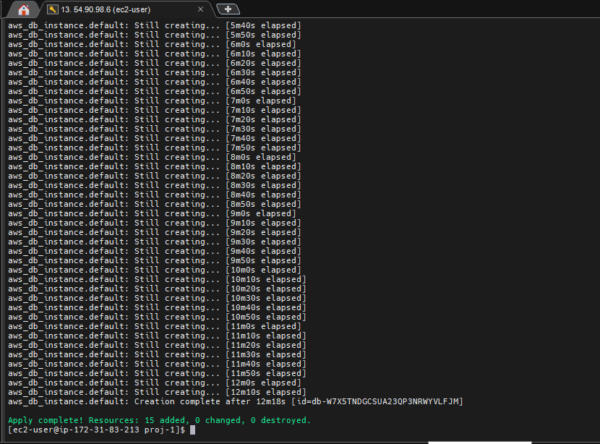

* Now checking the AWS resources ,

Ec2 instances created.

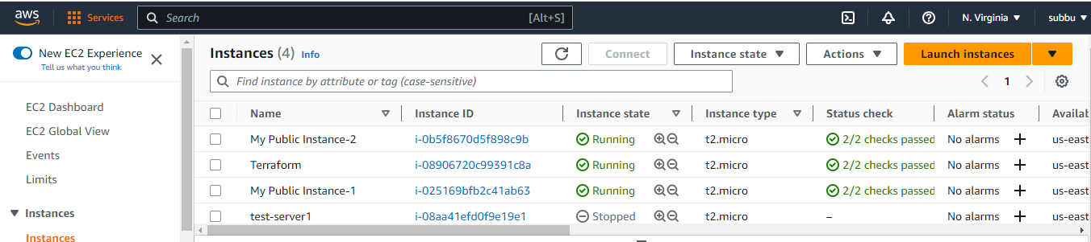

* Subnets created

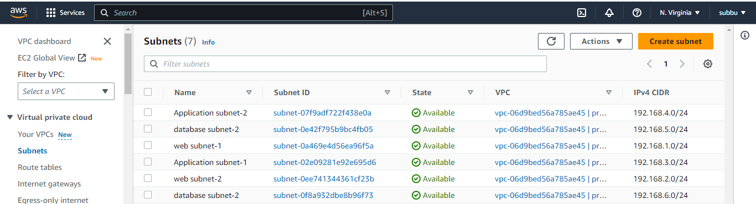

* Route created

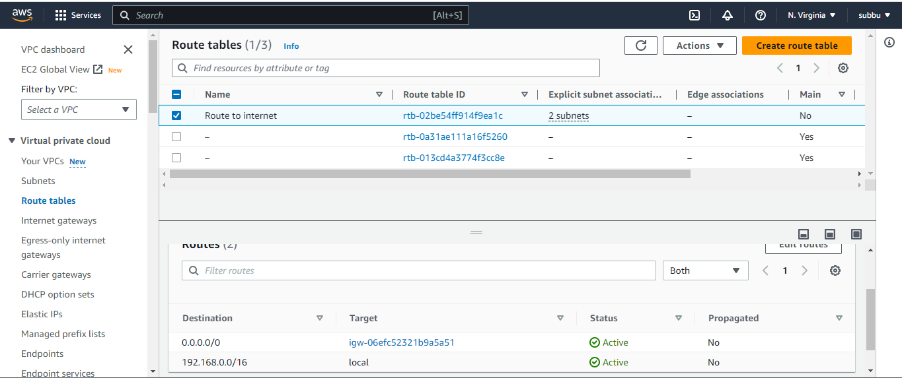

* Internet gateway created

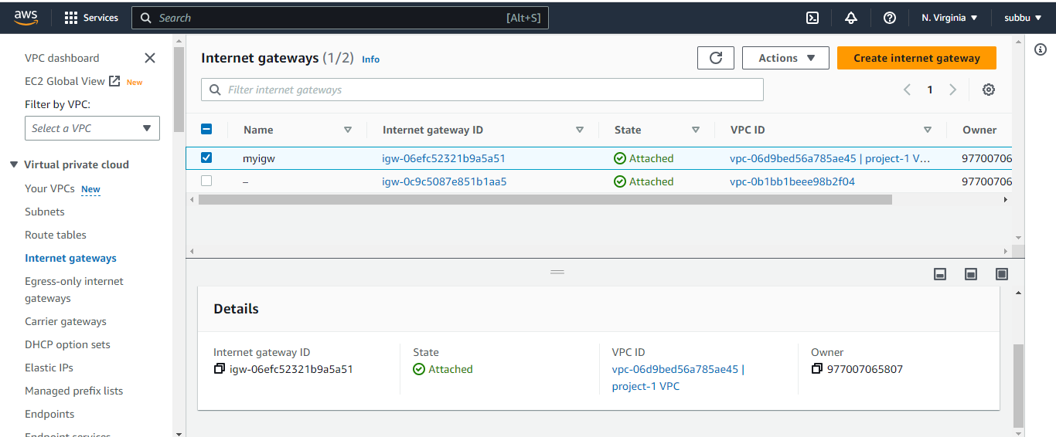

* Security groups created

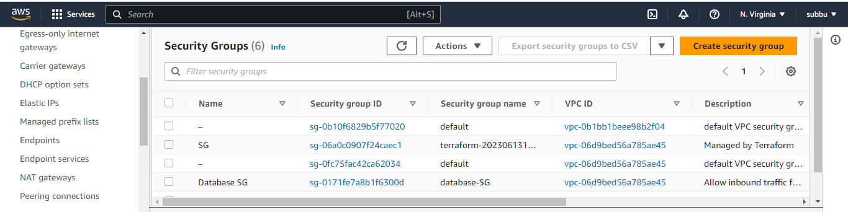

* Load balancer created

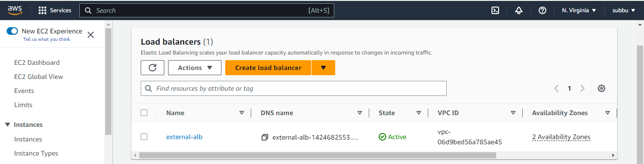

* RDS – Database is created

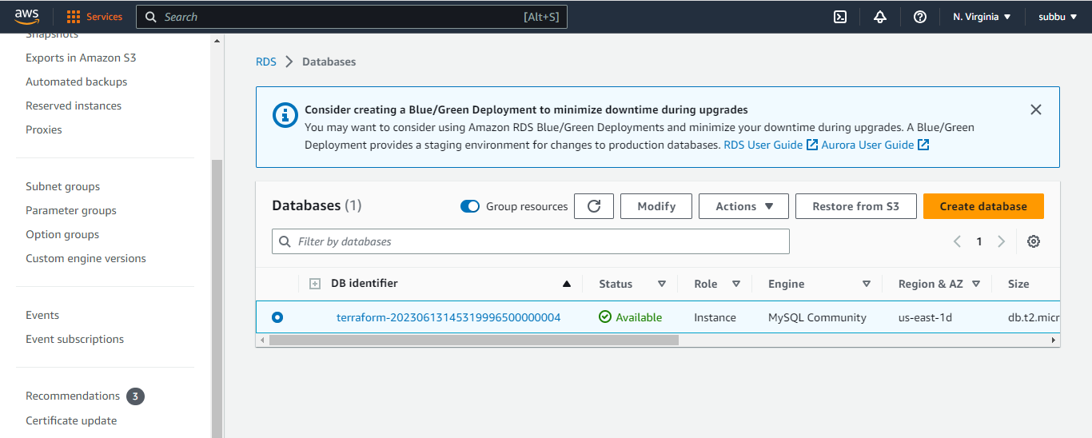

* Now Destroy the resources By using the command Terraform Destroy

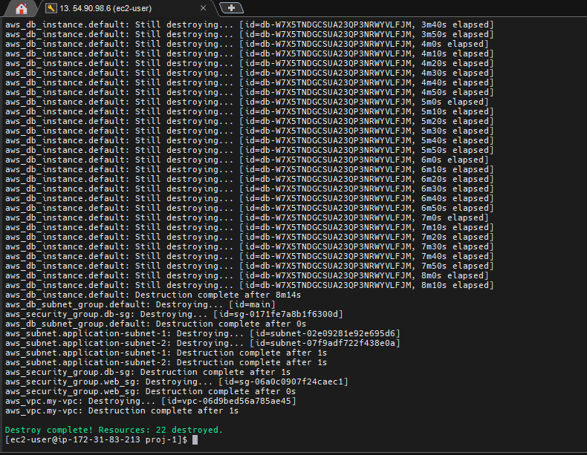

* All AWS resources are destroyed

*Verify the resource*

Terraform created below resources

Vpc

Public&private subnets

Route tables

Internet Gateway

EC2 instances

RDS instance

Application Load Balancer

Security Groups for web & RDS instance